**DH PRICE MOTORS LTD ENVIRONMENTAL POLICY STATEMENT**

**(UPDATED JULY 2024)**

DH Price Motors Ltd, acknowledges all of its responsibilities in protecting and preserving natural resources and other environmental assets. We aim to conduct all of our affairs in accordance with the dictates of sound environmental protection practices, including pollution prevention wherever reasonably possible.

DH Price Motors shall also avoid, minimise and appropriately mitigate adverse environmental impacts. These undertakings extend to the construction, maintenance and operation of all its systems and facilities. Legal obligations in these matters are established by applicable laws and regulations.

This policy statement is not intended to create further or additional legally enforceable requirements.

To support the performance of DH Price Motors Ltd responsibilities and undertakings, DH Price Motors Ltd is committed to:

* Implementing and maintaining and environmental management system that embraces all the company’s functions.
* Establish, maintain and make available to the public, appropriate performance indicators of the companies exercise of its environmental stewardship and to consistently review these indicators as a basis to improve our company performance.
* Comply with all environmental laws and regulations applicable to our business and activities.
* Assure that all DH Price Motors Ltd employees receive training appropriate to their functions concerning DH Price Motors Ltd environmental responsibilities.
* To communicate to contractors, designer’s, consultants and other participants in DH Price Motors Ltd work, the management practices and compliance requirements established to further the aims of this policy statement.
* To encourage employees and members of the public, such as our customer base, to communicate with us about ways to increase the effectiveness of the company practices and its environmental mission.

Each DH Price Motors Ltd employee is charged to exercise his or her responsibility on behalf of the company to assure that the intentions of this policy statement are carried out.

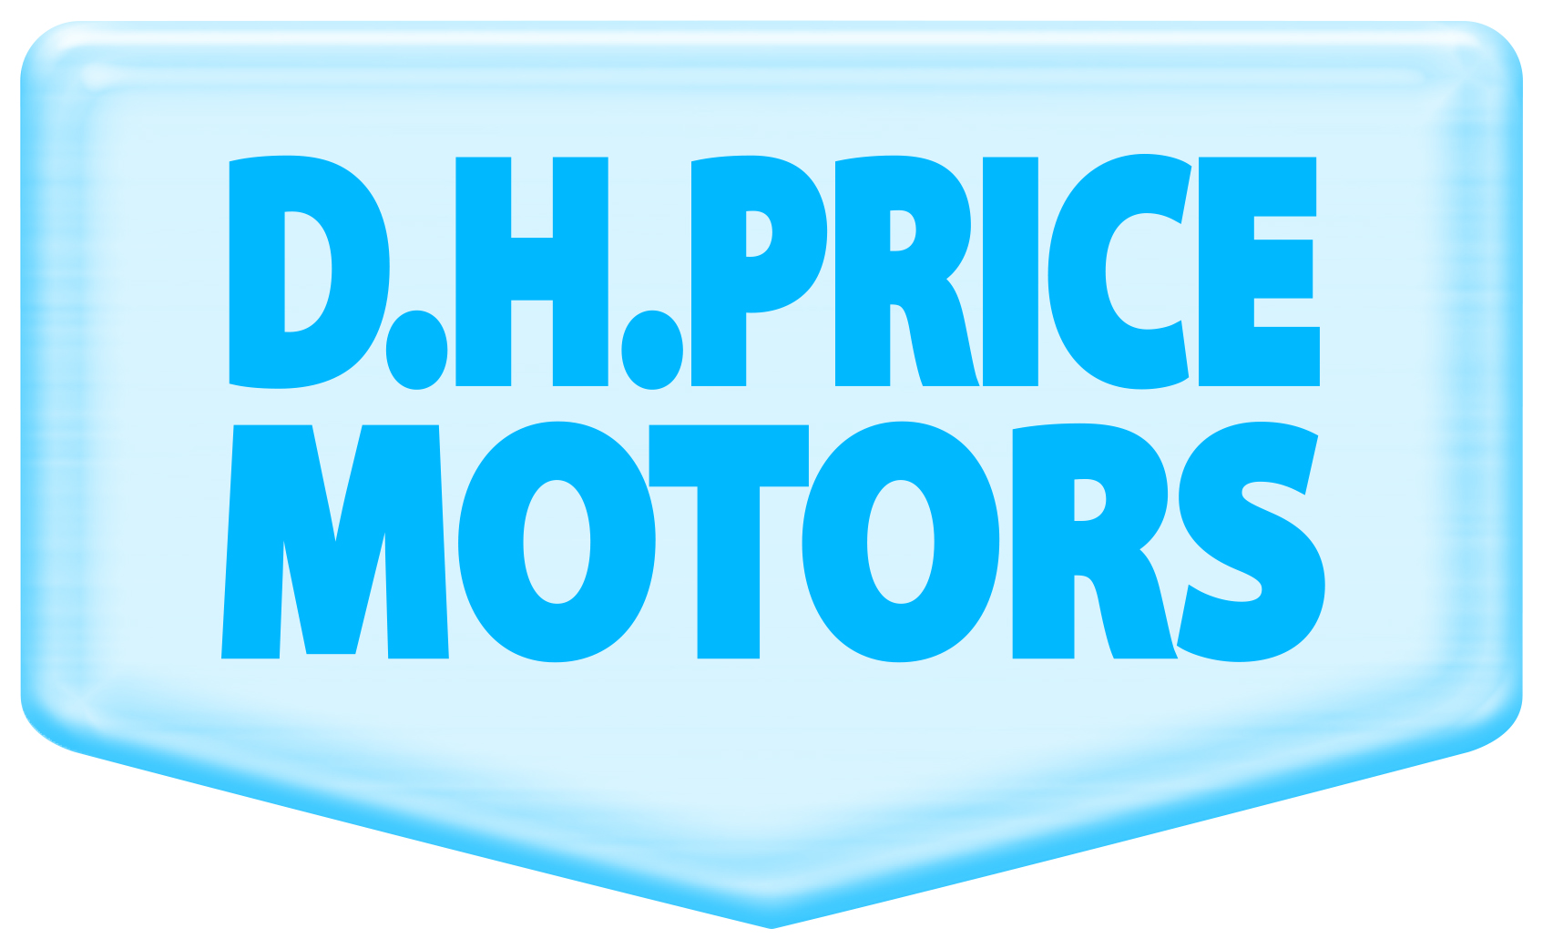

DH PRICE MOTORS LTD

“WHERE A GOOD SERVICE COMES AS STANDARD”